# Learning Outcome

After completing this module, the student should be able to configure an embedded database with different web pages using MongoDB

To meet the learning outcome, a student has to complete the following activities

1. Install of MongoDB in the system (2Hrs)
2. Create data with the following Data types - String, Integer, Boolean, double, min/max keys, arrays, timestamp, object, Null, symbol, date, object ID, Binary data, Code, Regular Expression (3Hrs)
3. Insert Document in database (1Hr)
4. Update document in database (1Hr)
5. Delete document in database (1Hr)
6. Project document in document (2Hr)
7. Create a MongoDB query to display all the documents in the collection data (Trainee’s data) (5Hrs)
8. Create a MongoDB query to display the fields id, trainee name, lab name, Certificate No., course title, course starting date, course ending date for all the documents in the collection trainees data. (5 Hrs)
9. Create a MongoDB query to display the fields id, trainee name, lab name, Certificate No., course name, course starting date, course ending date for all the documents in the collection trainees data, but excluding lab name (5 Hrs)

# Activity 1

## Aim: To install MongoDB in the computer system running with Ubuntu 18.04 LTS

**Learning outcome:** Able to configure embedded databases with different web pages using MongoDB.

**Duration:** 2 hour

**List of Hardware/Software requirements:**

1. Laptop/Computer with Linux OS - Ubuntu 18.04 LTS
2. MongoDB 4.2 Community Edition

**Installation Steps of MongoDB Community Edition:**

1. **Import the public key used by the package management system.**

From a terminal, issue the following command to import the MongoDB public GPG Key from <https://www.mongodb.org/static/pgp/server-4.2.asc>

wget -qO - https://[www.mongodb.org/static/pgp/server-4.2.asc](http://www.mongodb.org/static/pgp/server-4.2.asc) | sudo apt-key add –

The operation should respond with an OK.

However, if you receive an error indicating that gnupg is not installed, you can:

1. Install gnupg and its required libraries using the following command:

sudo apt-get install gnupg

1. Once installed, retry importing the key:

wget -qO - https://[www.mongodb.org/static/pgp/server-4.2.asc](http://www.mongodb.org/static/pgp/server-4.2.asc) | sudo apt-key add -

1. **Create a /etc/apt/sources.list.d/mongodb-org-4.2.list file for MongoDB.**

Create the list file using the command appropriate for your version of Debian:

echo "deb <http://repo.mongodb.org/apt/debian>buster/mongodb-org/4.2 main" | sudo tee/etc/apt/sources.list.d/mongodb-org-4.2.list

1. **Reload local package database.**

Issue the following command to reload the local package database:

sudo apt-get update

1. **Install the MongoDB packages**

To install the latest stable version, run command as following

sudo apt-get install -y mongodb-org

1. **Start MongoDB**

You can start the mongod process by issuing the following command:

sudo systemctl start mongod

1. **Begin using MongoDB.**

Run the following command

mongo

**References:**

● <https://docs.mongodb.com/manual/tutorial/install-mongodb-on-debian/>

# Activity 2

## Aim: Create MongoDB database with the following Data types – String, Integer, Boolean, double, min/max keys, arrays, timestamp, object, Null, symbol, date, object ID, Binary data, Code, Regular Expression

**Learning outcome:** Able to configure embedded databases with different web pages using MongoDB.

**Duration:** 3 hour

**List of Hardware/Software requirements:**

1. Laptop/Computer with Linux OS - Ubuntu 18.04 LTS
2. MongoDB 4.2 Community Edition
3. XAMPP- PHP 7
4. PHP-MongoDB driver 1.7.4 Create a Data:
5. **Insert a Document without Specifying an _id Field**

In the following example, the document passed to the insert() method does not contain the _id field:

db.products.insert( { item: "card", qty: 15 } )

**Output:**

{ "_id" : ObjectId("5063114bd386d8fadbd6b004"), "item" : "card", "qty" : 15 }

1. **Insert Multiple Documents**

The following example performs a bulk insert of three documents by passing an array of documents to the insert() method.

db.products.insert( [

{ _id: 11, item: "pencil", qty: 50, type: "no.2" },

{ item: "pen", qty: 20 },

{ item: "eraser", qty: 25 }

]

)

**Output:**

{ "_id" : 11, "item" : "pencil", "qty" : 50, "type" : "no.2" }

{ "_id" : ObjectId("51e0373c6f35bd826f47e9a0"), "item" : "pen", "qty" : 20 }

{ "_id" : ObjectId("51e0373c6f35bd826f47e9a1"), "item" : "eraser", "qty" : 25 }

We can either set the value of _id for each document or else _id value is assigned automatically. Let’s take a look at the example below

db.student.insertMany( [

{name : "Alex", age : 19}, {name : "Albert" , age : 20}, {name : "Bob" , age : 19}

]

)

Output:

{

"acknowledged" : true, "insertedIds" : [

ObjectId("5b680cbc80847beb3aa3e837"), ObjectId("5b680cbc80847beb3aa3e838"), ObjectId("5b680cbc80847beb3aa3e839")

]

}

**Reference:**

● <https://docs.mongodb.com/manual/reference/method/db.collection.insert/>

# Activity 3

## Aim: Insert Document in database

**Learning outcome:** Able to configure embedded databases with different web pages using MongoDB.

**Duration:** 1 hour

**List of Hardware/Software requirements:**

1. Laptop/Computer with Linux OS - Ubuntu 18.04 LTS
2. MongoDB 4.2 Community Edition
3. XAMPP- PHP 7
4. PHP-MongoDB driver 1.7.4

**Program:**

<?php

//connecting to database

if($con=new MongoDB\Driver\Manager("mongodb://localhost:27017")) echo "Database Connected";

//creating document as array

$doc=array("_id"=>"124", "Name"=>"John", "Age"=>"23", "Location"=>"India");

//creating write database object

$single_insert=new MongoDB\Driver\BulkWrite();

if($single_insert->insert($doc)) //preparing query statement for insert echo "<br>Document Insert Ready";

if($con->executeBulkWrite("mydb.mycol", $single_insert)) //executing write query echo "<br>Document Inserted";

?>

**Output:**

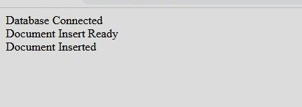

# Activity 4

## Aim: Update Document in database

**Learning outcome:** Able to configure embedded databases with different web pages using MongoDB.

**Duration:** 1 hour

**List of Hardware/Software requirements:**

1. Laptop/Computer with Linux OS - Ubuntu 18.04 LTS
2. MongoDB 4.2 Community Edition
3. XAMPP- PHP 7
4. PHP-MongoDB driver 1.7.4

**Program:**

<?php

//connecting database

if($con=new MongoDB\Driver\Manager("mongodb://localhost:27017")) echo "Database Connected";

//creating write object

$single_update=new MongoDB\Driver\BulkWrite();

//creating query for update

$single_update->update(["_id"=>"124"], ["Name"=>"Raj", "Age"=>"26"], ["multi"=>false, "upsert"=>false]);

//executing query for update

if($con->executeBulkWrite("mydb.mycol", $single_update)) echo "<br>Document Updated";

?>

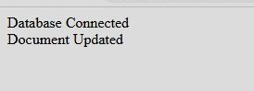**Output:**

# Activity 5

## Aim: Delete Document in database

**Learning outcome:** Able to configure embedded databases with different web pages using MongoDB.

**Duration:** 1 hour

**List of Hardware/Software requirements:**

1. Laptop/Computer with Linux OS - Ubuntu 18.04 LTS
2. MongoDB 4.2 Community Edition
3. XAMPP- PHP 7
4. PHP-MongoDB driver 1.7.4

**Program:**

<?php

//connecting database

if($con=new MongoDB\Driver\Manager("mongodb://localhost:27017")) echo "Database Connected";

//creating object for write

$del=new MongoDB\Driver\BulkWrite();

//creating delete query

$del->delete(["Name"=>"John"], ["limit"=>0]);

//executing delete query

if($con->executeBulkWrite("mydb.mycol", $del)) echo "<br>Document Deleted";

?>

**Output:**

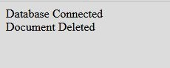

# Activity 6

## Aim: Project Document in database

**Learning outcome:** Able to configure embedded databases with different web pages using MongoDB.

**Duration:** 2 hours

**List of Hardware/Software requirements:**

1. Laptop/Computer with Linux OS - Ubuntu 18.04 LTS
2. MongoDB 4.2 Community Edition
3. XAMPP- PHP 7
4. PHP-MongoDB driver 1.7.4

**Program:**

<?php

//connecting to database

if($con=new MongoDB\Driver\Manager("mongodb://localhost:27017")) echo "Database Connected";

$filter=["Name"=>"Raj"]; //defining projection filter

$option=[]; //leaving options blank

$read=new MongoDB\Driver\Query($filter, $option); //creating query

$single_user=$con->executeQuery("mydb.mycol", $read); //executing query foreach($single_user as $user){ //foreach loop for traversing result displaying it

echo "<br>".$user->Name." is ".$user->Age." years old";

}

?>

**Output:**

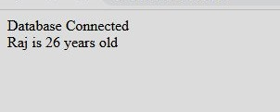

# Activity 7

## Aim: Create a MongoDB query to display all the documents in the collection data (Trainees data)

**Learning outcome:** Able to configure embedded databases with different web pages using MongoDB.

**Duration:** 5 hours

**List of Hardware/Software requirements:**

1. Laptop/Computer with Linux OS - Ubuntu 18.04 LTS
2. MongoDB 4.2 Community Edition
3. XAMPP- PHP 7
4. PHP-MongoDB driver 1.7.4

**Program:**

<?php

//connecting to database

if($con=new MongoDB\Driver\Manager("mongodb://localhost:27017")) echo "Database Connected<br><br>";

$filter=[]; //no filter

$option=[]; //no options

$read=new MongoDB\Driver\Query($filter, $option); //creating query

$single_user=$con->executeQuery("mydb3.mycol", $read); //executing query

//creating HTML table for displaying data echo "<table border=3 cellspacing=5

cellpadding=7><thead><th>ID<th>Name<th>Lab<th>Certificate No.<th>Course<th>Start Date<th>End Date</thead>";

foreach($single_user as $user){ //parsing through results in loop echo "<tr>";

echo

"<td>".$user->_id."<td>".$user->name."<td>".$user->lab."<td>".$user->certNo."<td>".$user->c ourse."<td>".$user->start."<td>".$user->end;

} //end of loop for parsing echo "</table>"; //end of table

?>

**Output:**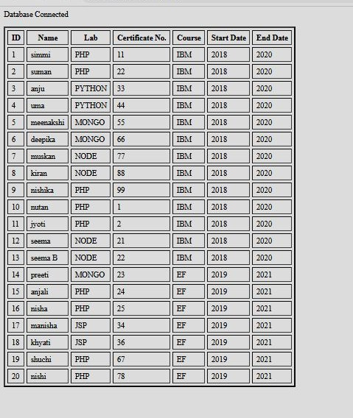

# Activity 8

## Aim: Create a MongoDB query to display the fields id, trainee name, lab name, Certificate No., course title, course starting date,course ending date for all the documents in the collection trainees data.

**Learning outcome:** Able to configure embedded databases with different web pages using MongoDB.

**Duration:** 5 hours

**List of Hardware/Software requirements:**

1. Laptop/Computer with Linux OS - Ubuntu 18.04 LTS
2. MongoDB 4.2 Community Edition
3. XAMPP- PHP 7
4. PHP-MongoDB driver 1.7.4

**Program:**

<?php

//connecting to database

if($con=new MongoDB\Driver\Manager("mongodb://localhost:27017")) echo "Database Connected<br><br>";

//no filters & no options applied

$filter=[];

$option=[];

//creating query object

$read=new MongoDB\Driver\Query($filter, $option);

//executing query and receive results

$single_user=$con->executeQuery("mydb3.mycol", $read);

//create table view

echo "<table border=3 cellspacing=5 cellpadding=7><thead><th>ID<th>Name<th>Certificate No.<th>Course<th>Start Date<th>End Date</thead>";

foreach($single_user as $user){ //parse through results using loop echo "<tr>";

echo

"<td>".$user->_id."<td>".$user->name."<td>".$user->certNo."<td>".$user->course."<td>".$user

->start."<td>".$user->end;

} //end of loop

echo "</table>"; //end of table

?>

**Output:**

# Activity 9

## Aim: Create a MongoDB query to display the fields id, trainee name, lab name, Certificate No., course name, course starting date, the course ending date for all the documents in the collection trainee’s data, but excluding lab name

**Learning outcome:** Able to configure embedded databases with different web pages using MongoDB.

**Duration:** 5 hours

**List of Hardware/Software requirements:**

1. Laptop/Computer with Linux OS - Ubuntu 18.04 LTS
2. MongoDB 4.2 Community Edition
3. XAMPP- PHP 7
4. PHP-MongoDB driver 1.7.4

**Program:**

<?php

//connecting to database

if($con=new MongoDB\Driver\Manager("mongodb://localhost:27017")) echo "Database Connected<br><br>";

$filter=[]; //no filters

$option=[ 'projection'=>['lab'=>0] ]; //options to eliminate lab column from result

$read=new MongoDB\Driver\Query($filter, $option); //creating query

$single_user=$con->executeQuery("mydb3.mycol", $read); //executing query

//creating table view without column for lab

echo "<table border=3 cellspacing=5 cellpadding=7><thead><th>ID<th>Name<th>Certificate No.<th>Course<th>Start Date<th>End Date</thead>";

foreach($single_user as $user){ //parsing results in loop echo "<tr>";

echo

"<td>".$user->_id."<td>".$user->name."<td>".$user->certNo."<td>".$user->course."<td>".$user

->start."<td>".$user->end;

} end loop

echo "</table>"; //end table

?>

**Output:**